Carbon Reduction Plan  *BUSINESS NAME* | *INSERT LOGO*


Emissions calculated using the Clean Growth UK Carbon Calculator. The calculator uses the UK Government greenhouse gas reporting conversion factors.

Carbon Reduction Plan

Business Description - add a brief description of what your business does and your commitment to net zero.

Commitment to achieving Net Zero

[Business Name] is committed to achieving Net Zero emissions by 20XX.

Baseline Emissions Footprint

Baseline emissions are the reference point against which emissions reduction can be measured.

The financial year 20xx – 20 xx has been selected as the baseline year.

This year the turnover was £ xxxxxxx.

The business had xx employees.

 | Baseline year: 20xx
 | Emissions |  | Total (tCO2e)
 | Scope1
 | Scope 2
 | Scope 3
 | Total
 | Additional info
 | Emissions per employee: |  | Emissions per £1k turnover:

Current Emissions footprint

This year the turnover was £ xxxxxxx.

The business had xx employees.

 | Reporting year: 20xx
 | Emissions |  | Total (tCO2e)
 | Scope1
 | Scope 2
 | Scope 3
 | Total
 | Additional info
 | Emissions per employee: |  | Emissions per £1k turnover:
add visuals, e.g.
- pie chart for breakdown of scopes 1, 2 and 3
- bar chart of emissions by source

Emissions Reductions

We have identified our carbon hotspots as: [list the categories with the highest values]
*
*
*
As a business we are committed to reducing our carbon footprint as a priority.

ACTIONS
Quick wins - Now (1-3 months)
[Add your actions here eg. review water efficiency equipment and upgrade, encourage staff to consider lower carbon options for commuting etc.]

Core Actions – Next (3-12 months)
[eg explore possibility of replacing boiler with heat pump, develop a waste strategy to reduce waste in operations and increase reuse and recycling etc.]

Transformational & innovative actions – Later (1 year plus)
[eg. collaborate with your supplier to xxx]

Commitments and targets

[Business name] overall goal is to align with the latest climate science and global targets of limiting global warming to 1.5° c.

We commit to reducing our carbon footprint by xx% by 2030. We commit to reduction our carbon footprint by 90% by 2050 [update if your net zero commitment is earlier than 2050]

Add graph showing pathway to 2050, e.g.

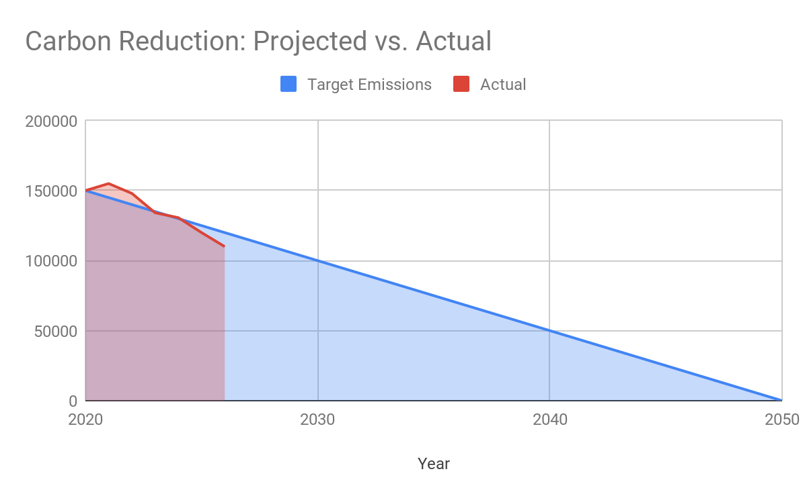

Investments

We have invested £ xxx in [add details of verified offset project] to reduce our carbon footprint by xxx tCO2e.

We have committed to and are investing other sustainability initiatives including:
Xxxx eg local tree planting, buying local, supplier choice [list initiatives as bullet points]

[add text supporting your commitment to climate action as a business and buy in at exec level]

Governance and reporting

We will report on progress annually and commit to the actions detailed in this plan. Our efforts will be boosted by the pace of decarbonisation of the national grid, heating infrastructure, transportation and innovations not yet developed.

This Carbon Reduction Plan is regarded as a live document, and the targets and actions will be reviewed regularly. This Carbon Reduction Plan is completed in compliance with PPN06/21 and associated guidance and reporting standards for Carbon Reduction Plans.

The Greenhouse Gas Protocol breaks emissions down into three categories (Scopes). This Carbon Reduction Plan focuses on reporting on Scope 1 and 2 emissions and the Scope 3 emissions that relate to our business, over which we have operational control.

Emissions have been reported and recorded in accordance with the published reporting standard for Carbon Reduction Plans and the GHG Reporting Protocol corporate standard and uses the appropriate government emission conversion factors for greenhouse gas company reporting.

By signing this document [business name] acknowledges that it now has a clear understanding of the key emissions in its organisation and commits to taking action to reduce them.

Signed

Name

Title

